**DISEASE RECOGNITION USING X-RAY IMAGES USING DEEP LEARNING**

Submitted In Partial Fulfillment Of The Requirements Of The Degree Of Bachelor Of Artificial Intelligence And Machine Learning

By

**Mr. Harsh Chauhan (12)**

**Mr. Prince Tiwari (99)**

**Mr. Siddhant Vanarase (102)**

Supervisor:

# Prof. Shraddha Shah



**Department Of Artificial Intelligence And Machine Learning**

**VIDYA VIKAS EDUCATION TRUST’S**

**UNIVERSAL COLLEGE OF**

**ENGINEERING KAMAN, VASAI - 401208**

**UNIVERSITY OF MUMBAI**

**2024-2025**

**Vidya Vikas Education Trust’s**

**Universal College of Engineering, Vasai (E)**

Department of Artificial Intelligence and Machine Learning



**CERTIFICATE**

This is to certify that, the Major Project entitled **“Disease Recognition Using X-Ray Images Using Deep Learning”** is the bonafide work of **Mr. Harsh Chauhan (12), Mr. Prince Tiwari (99), and Mr. Siddhant Vanarase (102)** submitted to the University of Mumbai in fulfillment of the requirement for the Major Project-I Semester VII project work of B.E. Artificial Intelligence and Machine Learning at Universal College of Engineering, Vasai, Mumbai at the Department of Artificial Intelligence and Machine Learning, in the academic year 2024-2025, Semester – VII.

Prof. Shraddha Shah

**Internal Examiner External Examiner**

Mrs. Poonam Thakre Dr. J. B. Patil

**Head of Department Principal**

# Major Project-I Report Approval

This project report entitled “” by Mr. Harsh Chauhan, Mr. Prince Tiwari, and Mr. Siddhant Vanarase is approved for the Major Project-I Semester VII project work of B.E Artificial Intelligence and Machine Learning at Universal College of Engineering, Vasai, in the academic year 2024-2025.

##### Internal Examiner External Examiner

Date:

# Declaration

I declare that this written submission represents my ideas in my own words and where others’ ideas or words have been included, I have adequately cited and referenced the original sources. I also declare that I have adhered to all principles of academic honesty and integrity and have not misrepresented or fabricated or falsified any idea/data/fact/source in my submission. I understand that any violation of the above will be cause for disciplinary action by the Institute and can also evoke penal action from the sources which have thus not been properly cited or from whom proper permission has not been taken when needed.

**Mr. Harsh Chauhan (12)**

**Mr. Prince Tiwari (99)**

**Mr. Siddhant Vanarase (102)**

Date:

**Contents**

List of Figures

List of Tables

List of Abbreviations

Abstract 01

### INTRODUCTION

* 1. Project Overview 02

### REVIEW OF LITERATURE

* 1. Existing System 04
  2. Literature Survey 05
  3. Problem Statement and Objective 06
  4. Scope 07

### PROPOSED SYSTEM

* 1. Analysis/Framework/Algorithm 08
  2. System Requirements 09
     1. Hardware Requirements
     2. Software Requirements
  3. Design Details 10
     1. System Architecture
  4. Data Model and Description 11
     1. Gantt Chart
  5. Fundamental Model 12
     1. Data Flow Model
  6. Unified Modelling Language Diagram
     1. Use Case Diagram 14
     2. Activity Diagram 15
     3. Sequence Diagram 16
     4. Component Diagram 16
  7. Methodology 17

### RESULTS

* 1. Proposed System Result 19
  2. Comparison between existing and proposed system 23

**Conclusion** 24

**Appendix** 25

**Literature Cited**  27

**Acknowledgement** 28

**List Of Figures**

|  |  |  |
| --- | --- | --- |
| **Figure No** | **Description** | **Page No** |
| **3.3.1** | System Architecture. | **10** |
| **3.4.1** | Gantt Chart | **11** |
| **3.5.1** | DFD Level 0 | **12** |
| **3.5.1.a** | DFD Level 1 | **13** |
| **3.6.1** | Use Case Diagram | **14** |
| **3.6.2** | Activity Diagram | **15** |
| **3.6.3** | Sequence Diagram | **16** |
| **3.6.4** | Component Diagram | **16** |
| **4.1.1** | Model Building | **19** |
| **4.1.2** | Confusion Matrix | **20** |
| **4.1.3** | ROC Curve | **21** |
| **4.1.4** | Model Accuracy & Model Loss | **22** |

**List Of Tables**

|  |  |  |
| --- | --- | --- |
| **Figure No** | **Description** | **Page No** |
| **2.2** | Literature Survey | **5** |
| **4.2** | Proposed System Versus Existing System | **23** |

# List Of Abbreviations

|  |  |
| --- | --- |
| **Abbreviations** | **Description** |
| **PACS** | Picture Archiving and Communication Systems |
| **CNNs** | Convolutional Neural Networks |
| **DenseNet** | Densely Connected Convolutional Networks |

# Abstract

Chest X-rays are vital tools in medical imaging, providing reliable radiobiological imprints that help diagnose a range of conditions affecting the organs within the chest. Despite their critical role in healthcare, a significant amount of valuable imaging data and corresponding diagnoses has remained largely underutilized, trapped within Picture Archiving and Communication Systems (PACS) in hospitals and medical institutions. Chest X-Rays are considerably reliable radiobiological imprints of patients, which are widely used to diagnose an array of common diseases affecting organs within the chest. For too long, vast accumulations of image data and their associated diagnoses have been stored in the Picture Archiving and Communication Systems (PACS) of several hospitals and medical institutions. Meanwhile, data-hungry deep learning systems lie in wait of voluminous databases like these, at the cusp of fulfilling the promise of automated and accurate disease diagnosis. Through this project, we hope to unite one such vast database, the “ChestX-ray8" dataset, with a powerful deep Learning system.

**Chapter 1**

**Introduction**

**1.1 Project Overview:**

Pneumonia is a life-threatening infection that primarily affects the lungs and is especially dangerous in children, the elderly, and immunocompromised individuals. Diagnosing pneumonia early can significantly improve patient outcomes, but the manual analysis of chest X-rays by radiologists is time-consuming and prone to human error. With the advancements in deep learning, machine learning models, specifically Convolutional Neural Networks (CNNs), have been employed to automate and enhance the accuracy of pneumonia detection.

The existing project utilizes CNNs for pneumonia detection, achieving moderate success. However, due to limitations like the vanishing gradient problem and lack of efficient feature reuse, there is a need for improvement. To address these challenges, this project extends the existing model by employing Dense Net, an advanced architecture designed to enhance feature reuse and improve gradient flow across deeper layers. The proposed system will analyze chest X-ray Images, leveraging the power of DenseNet to provide faster, more accurate, and efficient diagnosis of pneumonia, which can assist radiologists in clinical decision-making.

Pneumonia remains a leading cause of morbidity and mortality worldwide, emphasizing the need for efficient and accurate diagnostic tools. This project aims to develop a deep learning-based system specifically designed for the recognition of pneumonia from X-ray Images. By leveraging state-of-the-art deep learning architectures, particularly convolutional neural networks (CNNs), the system will analyze X-ray IMAGES to extract critical features indicative of pneumonia. Our goal is to create a robust and reliable disease recognition system that not only enhances the speed and accuracy of diagnoses but also aids healthcare professionals in making informed decisions, ultimately improving patient outcomes and facilitating early intervention.

Pneumonia remains a leading cause of morbidity and mortality worldwide, and early diagnosis is crucial for effective treatment. However, interpreting X-ray Images can be challenging, often requiring significant expertise and experience. Traditional diagnostic methods may lead to delays or inaccuracies. This project seeks to harness the power of deep learning to automate and enhance the recognition of pneumonia from X-ray Images, providing healthcare professionals with a reliable diagnostic tool.

Curate a comprehensive dataset of X-ray Images, focusing on those diagnosed with pneumonia as well as normal cases for comparison. Utilize publicly available datasets (e.g., Chest X-ray datasets) and collaborate with medical institutions to obtain additional anonymized X-ray Images.

Implement preprocessing techniques, such as normalization, resizing, and augmentation, to enhance image quality and increase dataset diversity. Employ techniques like histogram equalization to improve contrast and visibility in X-ray Images.

Develop a CNN architecture optimized for pneumonia detection, potentially utilizing transfer learning from pre-trained models (e.g., VGG16, ResNet) to enhance performance. Experiment with various architectures and fine-tune hyperparameters to achieve the best results.

**Chapter 2**

**Review of Literature**

* 1. **Existing System:**

Pneumonia is a potentially life-threatening infectious disease that is typically diagnosed through physical examinations and diagnostic imaging techniques such as chest X-rays, ultrasounds, or lung biopsies. Accurate diagnosis is crucial as wrong diagnosis, inadequate treatment or lack of treatment can cause serious consequences for patients and may become fatal. The advancements in deep learning have significantly contributed to aiding medical experts in diagnosing pneumonia by assisting in their decision-making process. By leveraging deep learning models, healthcare professionals can enhance diagnostic accuracy and make informed treatment decisions for patients suspected of having pneumonia. In this study, six deep learning models including CNN, InceptionResNetV2, Exception, VGG16, ResNet50 and EfficientNetV2L are implemented and evaluated. The study also incorporates the Adam optimizer, which effectively adjusts the epoch for all the models.

This study evaluates six deep learning models: CNN, InceptionResNetV2, EfficientNetV2L, VGG16, ResNet50, and Exception. Each model is assessed for its diagnostic accuracy in identifying pneumonia. Additionally, the study incorporates the Adam optimizer to effectively adjust training epochs across all models, optimizing their performance. By leveraging these deep learning techniques, healthcare professionals can improve diagnostic precision and make better-informed treatment decisions for patients suspected of having pneumonia.

* 1. **Literature Survey:**

|  |  |  |  |  |
| --- | --- | --- | --- | --- |
| **Paper No.** | **Paper Title** | **Year** | **Advantages** | **Dis-Advantages** |
| **1** | Radiologist level accuracy using deep learning for haemorrhage detection in CT scans. | 2018 | * Improved Accuracy * Enhanced Recall | * Complexity * Dependence on High-Quality Data |
| **2** | Detecting SARS-CoV-2 From Chest X-Ray Using Artificial Intelligence. | 2021 | * High accuracy * Improved performance with larger dataset | * Limited dataset * Lack of subgroup analysis |
| **3** | Pneumonia Detection in Chest X-Rays using Neural Networks. | 2022 | * Good performance * Limited resources | * Lower MAP score * Room for improvement |
| **4** | Pneumonia Detection on Chest X-ray Images Using Ensemble of Deep Convolutional Neural Networks. | 2022 | * Improved accuracy * Efficient | * Complexity * Dependence on pre-trained models |
| **5** | Design and Analysis of a Deep Learning Ensemble Framework Model for the Detection of COVID-19 and Pneumonia Using Large-Scale CT Scan and X-ray Image Datasets. | 2023 | * Improved F-Score * Efficient Detection | * Large dataset requirement * Limited Interpretability |
| **6** | A Deep Convolutional Neural Network for Pneumonia Detection in X-ray Images with Attention Ensemble. | 2024 | * Effectiveness * Potential | * Overfitting * Bias |
| **7** | Deep Learning for Pneumonia Detection in Chest X-ray Images: A Comprehensive Survey. | 2024 | * Automation * Cost-effective | * Limited availability of data and code * Vulnerability of adversarial attacks |

**Table 2.2 Literature Survey**

* 1. **Problem Statement And Objective:**

The increasing prevalence of pneumonia poses significant challenges to healthcare systems, particularly regarding timely and accurate diagnosis. Traditional methods of interpreting X-ray Images can be subjective and time-consuming, often leading to delays in treatment. As a result, there is a critical need for an automated, deep learning-based system that can efficiently analyze X-ray IMAGES and accurately identify pneumonia. The variability in imaging quality and the presence of overlapping conditions further complicate diagnosis, underscoring the necessity for a robust solution that minimizes errors and enhances diagnostic capabilities.

To address these challenges, this project aims to develop a deep learning-based system utilizing advanced convolutional neural networks (CNNs) for the accurate and efficient recognition of pneumonia from X-ray Images. Key objectives include compiling a comprehensive dataset of X-ray Images labelled for pneumonia and normal conditions, designing, and implementing CNN architectures tailored for feature extraction and classification, assessing the model's accuracy and performance against existing benchmarks, and creating a user-friendly interface for healthcare professionals. This integrated approach aims to facilitate early diagnosis, ultimately improving patient outcomes and streamlining clinical workflows.

* 1. **Project Scope:**

The project, “Disease recognition system using x-ray IMAGES” aims to design, develop, focus on a specific set of diseases that can be accurately diagnosed using X-ray Images (e.g., pneumonia, lung cancer, fractures). Consider the impact of image quality on the system's performance and explore techniques to handle low-quality Images. Investigate potential deployment platforms and considerations for real-world applications. Address ethical concerns related to data privacy, bias, and the impact of AI on healthcare. The scope of the project includes the design, development, and testing of a pneumonia detection system that leverages DenseNet. This system is expected to:

1. Provide a robust and accurate diagnosis tool for pneumonia detection.
2. Serve as a decision-support system for radiologists, helping them diagnose patients more quickly and accurately.
3. Offer a modular framework that can be adapted to detect other lung-related diseases in the future (e.g., tuberculosis, lung cancer).
4. Integrate seamlessly into clinical environments, offering potential for real-time deployment in hospitals or mobile healthcare units.

**Chapter 3**

**Proposed System**

* 1. **Analysis/Framework/ Algorithm:**

In the context of our disease recognition system using X-ray IMAGES, the DenseNet algorithm presents a robust framework for effectively identifying various diseases from medical Images. DenseNet, or Densely Connected Convolutional Networks, is a type of convolutional neural network (CNN) known for its innovative architecture that enhances feature propagation and reuse.

**Dense Connectivity**: Unlike traditional CNN architectures where each layer is connected only to the subsequent layer, DenseNet connects each layer to every other layer. This dense connectivity allows for the efficient sharing of features, enabling the model to leverage previous layers’ outputs as inputs to subsequent layers. This promotes a richer feature representation, which is particularly beneficial in medical imaging where subtle differences can indicate various diseases.

**Improved Gradient Flow**: DenseNet alleviates the vanishing gradient problem, which is common in deep networks. By maintaining direct connections between layers, the gradients can flow more freely during backpropagation, facilitating more effective training even in very deep networks. This characteristic is crucial for training complex models that require learning intricate patterns from X-ray Images.

**Parameter Efficiency**: DenseNet achieves high accuracy with fewer parameters compared to traditional CNNs. The feature reuse mechanism reduces redundancy, allowing the model to maintain performance while being computationally efficient. This efficiency is essential in clinical settings where quick inference times are necessary.

**Bottleneck Layers**: To further optimize performance, DenseNet often employs bottleneck layers that reduce the dimensionality of feature maps before passing them through convolutional layers. This approach not only decreases computational load but also helps the model focus on the most relevant features for disease recognition.

**3.2 System Requirements:**

**3.2.1 Hardware Requirements:**

1. **GPU:** To accelerate the training process, a high-performance GPU like the NVIDIA RTX 3080 or above is recommended, as the DenseNet model involves heavy computation due to its dense connections.
2. **RAM:** A minimum of 16 GB of RAM is required to handle large image datasets and the memory-intensive computations of DenseNet.
3. **Storage:** At least 500 GB of storage space is necessary for storing the dataset, model weights, and intermediate results during the training process.
   * 1. **Software Requirements:**
4. **Python:** The implementation will be done using Python (version 3.7 or higher).
5. **TensorFlow/Keras or PyTorch:** These deep learning frameworks will be used for building and training the DenseNet model.
6. **OpenCV:** OpenCV will be used for image processing tasks such as image resizing, normalization, and augmentation.
7. **CUDA:** NVIDIA’s CUDA library is required to parallelize computations and utilize the GPU efficiently.
8. **Jupyter Notebook**: For coding, experimentation, and documentation purposes.
   1. **Design Details:**
      1. **System Architecture:**

**Fig. 3.3.1: System Architecture.**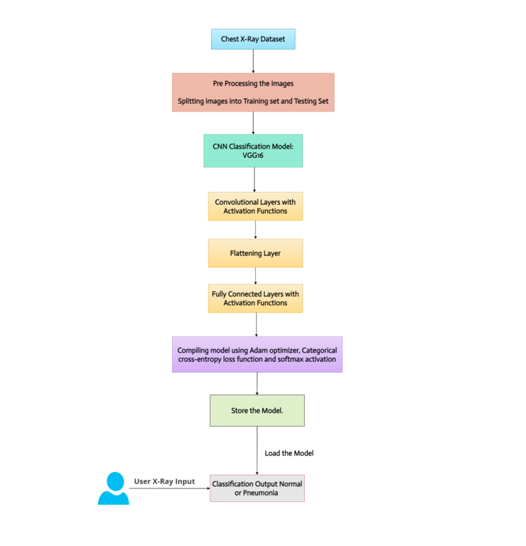

* 1. **Data Model and Description:**
     1. **Gantt Chart:**

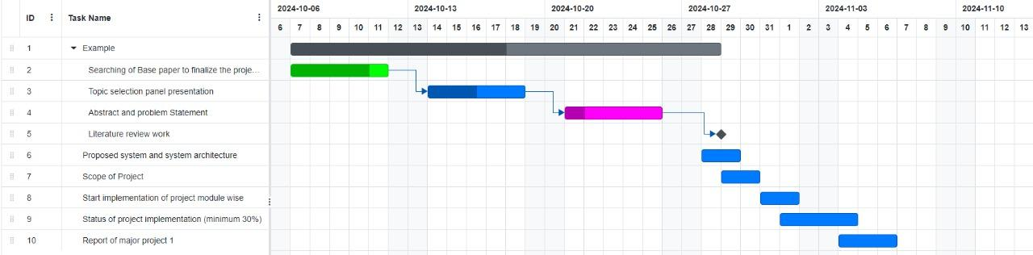

**Fig 3.4.1 Gantt Chart**

The image presents a Gantt chart outlining the sequence and duration of tasks for a project. It consists of ten tasks, each represented by colored bars that indicate the timeline for their completion. The first task is an example task, which spans a significant portion of the timeline. The second task, focused on searching for a base paper to finalize the project, is marked with a green bar, showing its duration. Following this, the third task involves topic selection and a panel presentation, represented by a blue bar. As the project progresses, tasks like the abstract and problem statement, literature review, and proposed system and architecture are scheduled sequentially. Each task is dependent on the completion of the previous one, with arrows indicating dependencies between them. Later tasks include the scope of the project, the start of implementation, and status updates on the progress, culminating in the final report of the major project. The Gantt chart visually organizes the project’s tasks, providing a clear timeline for each step to ensure proper execution and completion.

* 1. **Fundamental Model:**
     1. **Data Flow Model:**

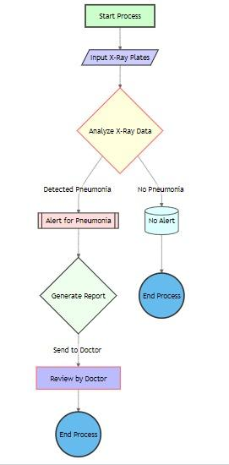

**Fig 3.5.1 DFD Level 0**

The flowchart outlines the process of pneumonia detection using X-ray plates. If pneumonia is detected, an alert is generated, a report is created, and the report is sent to a doctor for review. If no pneumonia is detected, no alert is generated and the process ends.

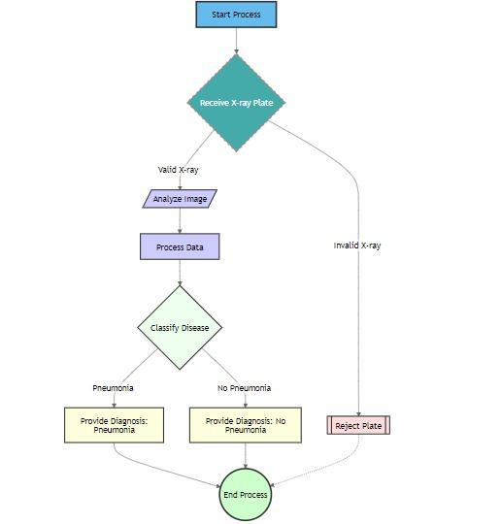

**Fig 3.5.1.a DFD Level 1**

The flowchart depicts the process of diagnosing pneumonia using X-ray plates. It starts by receiving an X-ray plate and validating its quality. If valid, the image is analyzed and processed to extract relevant features. A machine learning model then classifies the image as either pneumonia or no pneumonia. Based on the classification result, a diagnosis is provided, and the process ends. If the X-ray plate is invalid, it is rejected, and the process ends.

* 1. **UML (Unified Modelling Language) Diagram:**
     1. **Use Case Diagram:**

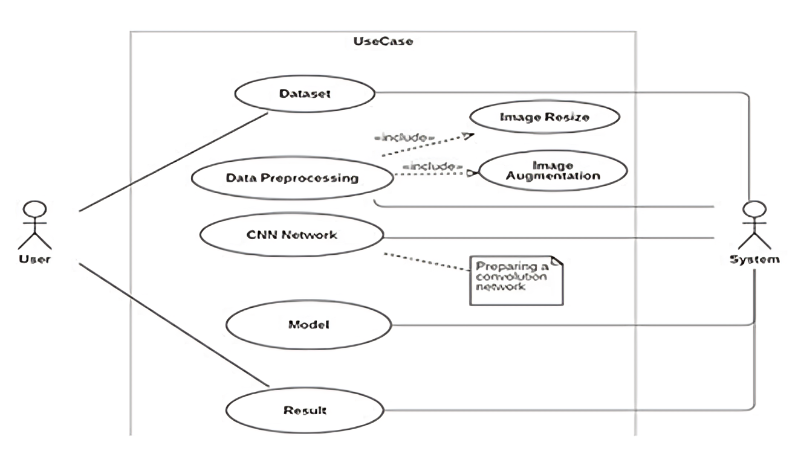

**Fig 3.6.1 Use Case Diagram**

The diagram illustrates the workflow of an image classification system using a Convolutional NeuralNetwork (CNN). It involves two primary actors: the User and the System. The process begins when the user provides a Dataset, which undergoes two key preprocessing steps: Image Resize and Image Augmentation. These steps ensure the images are standardized in size and enhanced through various transformations, such as rotation or scaling, to improve the model's performance. After the preprocessing, the data is fed into the CNN Network, where a convolutional architecture is prepared to extract essential features from the images. Once the CNN is fully set up, the system uses the processed data to train and build the Model. This trained model is then used to classify the images and generate a final Result. Throughout the entire process, the System handles the computational tasks, and the User receives the output, representing a complete cycle of building and deploying a CNN-based image classification model.

* + 1. **Activity Diagram:**

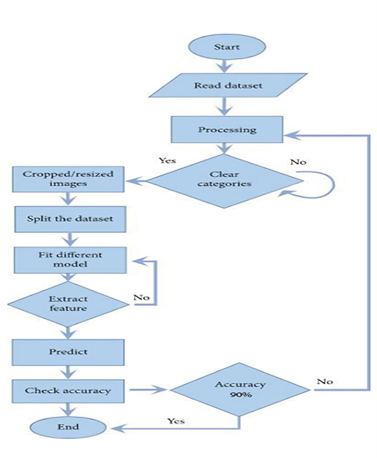

**Fig 3.6.2 Activity Diagram**

The flowchart outlines the process of pneumonia detection. It begins with reading a dataset and processing the images. The images are then cropped or resized, and the dataset is split. Different models are fitted to the data, and features are extracted. After prediction, the accuracy is checked. If the accuracy is below 90%, the process repeats with different models or feature extraction techniques.

* + 1. 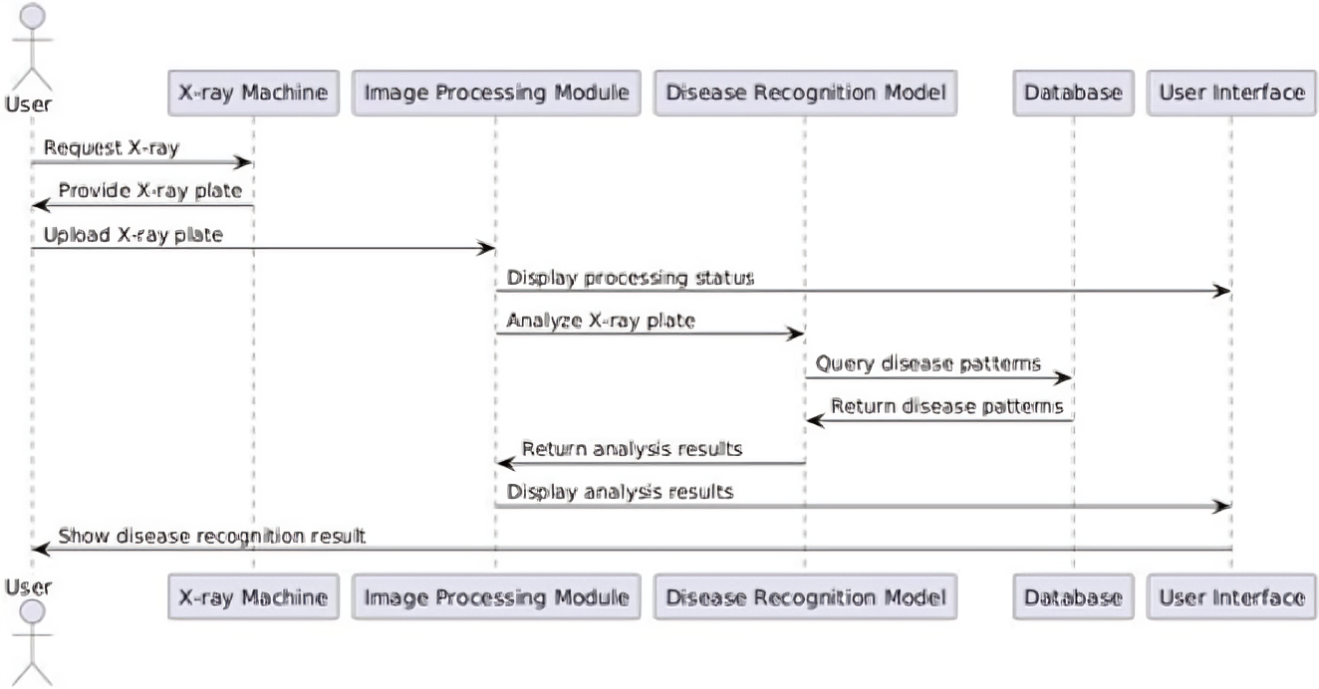 **Sequence Diagram:**

**Fig 3.6.3 Sequence Diagram**

The image depicts a sequence diagram illustrating the workflow of a pneumonia detection system. A user requests an X-ray, which is then processed by an image processing module. The processed image is analyzed by a disease recognition model, which queries a database for disease patterns. Finally, the analysis results are displayed to the user.

* + 1. **Component Diagram:**

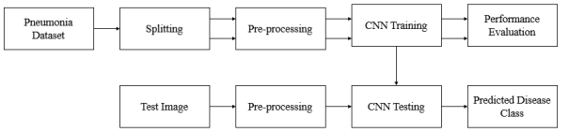

**Fig 3.6.4 Component Diagram**

The image demonstrates the workflow of a pneumonia detection system. The system begins with a pneumonia dataset that is split into training and testing sets. Preprocessing is applied to both sets before training a convolutional neural network (CNN). After training, the model is evaluated on the testing set to assess its performance. Finally, a new test image is preprocessed and fed into the trained CNN to predict the disease class.

* 1. **Methodology**

The methodology employed in this project for developing a deep learning-based system for disease recognition from X-ray Images encompasses several key steps. First, a comprehensive literature review was conducted to understand the current state of deep learning applications in medical imaging, identifying gaps that our system could address. We sourced a diverse dataset of annotated X-ray Images, such as the ChestX-ray14 dataset, ensuring a broad representation of various diseases. To enhance this dataset, we applied data augmentation techniques like rotation, flipping, and brightness adjustments, which helped improve the model's robustness against overfitting.

Preprocessing involved normalizing the Images by resizing them to a consistent dimension and scaling pixel values to a standard range. Noise reduction techniques, such as Gaussian filtering, were employed to minimize any noise in the Images, and segmentation was used where applicable to focus on relevant anatomical features. For model selection, we chose state-of-the-art convolutional neural networks (CNNs), including architectures like ResNet and DenseNet, and considered transfer learning with pre-trained models to leverage existing feature extraction capabilities. In some cases, a custom architecture was developed to better fit the dataset characteristics.

During the training phase, the dataset was split into training, validation, and test sets. We implemented a suitable loss function, such as cross-entropy, and used the Adam optimizer with a learning rate schedule to enhance convergence. Regularization techniques like dropout and batch normalization were applied to mitigate overfitting, while hyperparameter tuning was conducted to optimize model performance. The evaluation of the model involved assessing its accuracy, precision, recall, F1 score, and AUC-ROC, along with analyzing the confusion matrix to identify misclassifications.

Post-processing included the use of interpretability techniques like Grad-CAM to visualize important regions influencing the model's predictions. Ensemble methods were also considered to combine predictions from multiple models for improved accuracy. The model underwent rigorous validation on unseen test sets and external datasets to ensure its reliability and generalization. For deployment, we developed a user-friendly interface for clinicians to input X-ray Images and receive predictions, alongside creating an API for integration with existing healthcare systems. Finally, ethical considerations were addressed, focusing on data privacy, model bias, and regulatory compliance, while establishing a feedback mechanism for continuous improvement of the model using new data. This comprehensive methodology underpins the project's goal of creating a robust and reliable disease recognition system to aid in early diagnosis and improve patient outcomes.

**Chapter 4**

**Result and Discussion**

**4.1 Proposed System Result:**

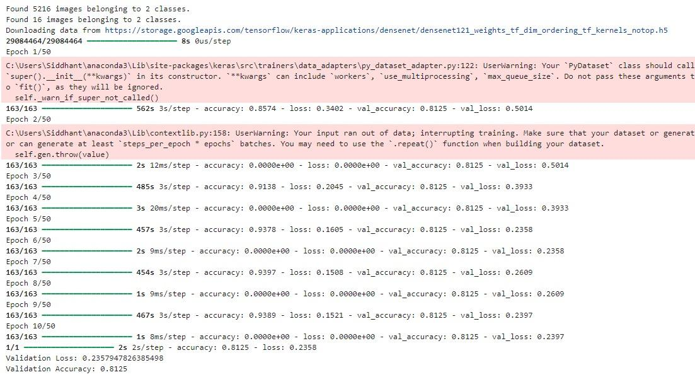

**Fig 4.1.1 Model Building**

The provided text output describes the training process of a convolutional neural network (CNN) model for pneumonia detection. The dataset contains 5216 images belonging to two classes: pneumonia and normal. The CNN model is based on the DenseNet121 architecture, with pre-trained weights. The model is trained for 50 epochs, with an initial learning rate of 0.001. During training, the accuracy and loss are monitored for both the training and validation sets. The validation accuracy plateaus at around 81.25%, indicating that the model is not overfitting but may benefit from further tuning or additional data. The final validation loss is 0.2358, suggesting that the model has learned to differentiate between pneumonia and normal cases to a reasonable extent. However, further analysis and improvements would be necessary to achieve higher accuracy and reliability for real-world applications.

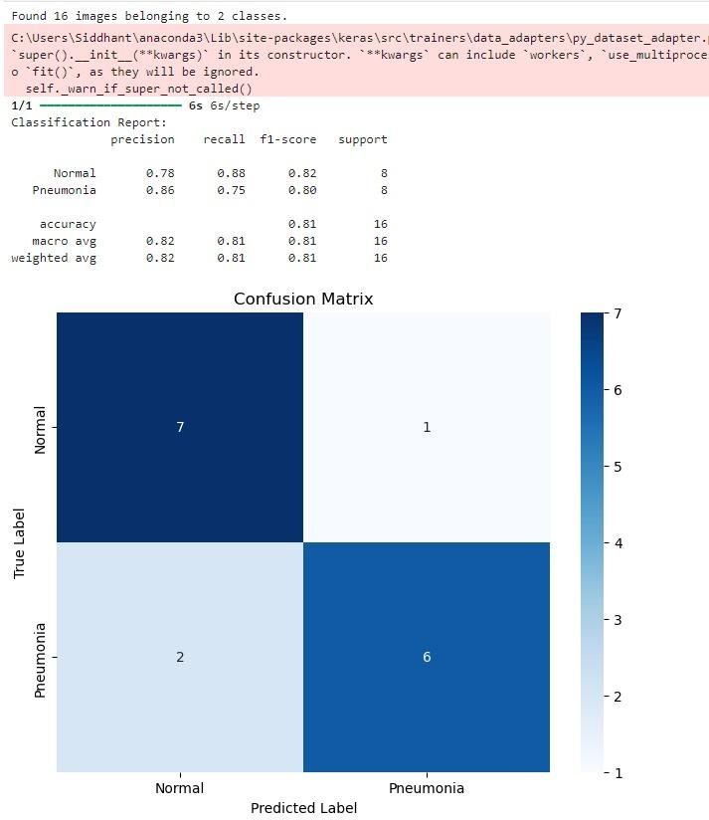

**Fig 4.1.2 Confusion Matrix**

The provided text output presents the evaluation metrics for a pneumonia detection model. The model achieved an overall accuracy of 81%, with precision, recall, and F1-score values ranging from 0.75 to 0.88 for both pneumonia and normal classes. The confusion matrix shows that the model correctly classified 7 out of 8 normal cases and 6 out of 8 pneumonia cases. These results indicate that the model is performing well in detecting both pneumonia and normal cases, but further improvements may be needed to achieve higher accuracy and reliability.

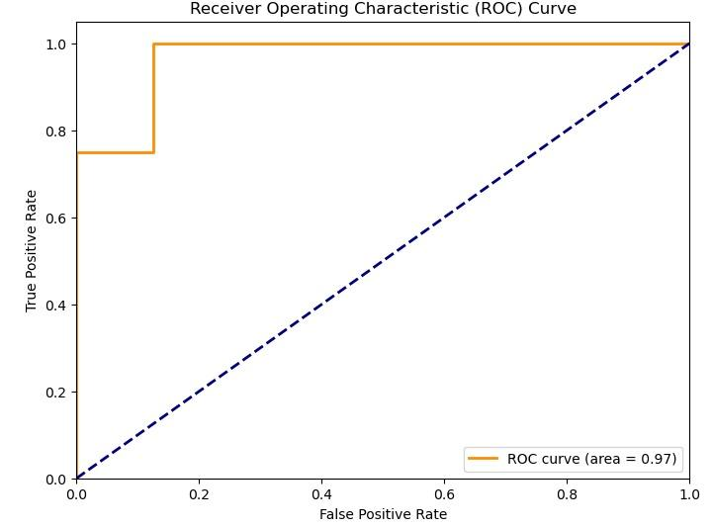

**Fig 4.1.3 ROC Curve**

The provided image depicts a Receiver Operating Characteristic (ROC) curve, which is a graphical representation of a binary classification model's performance. The x-axis represents the False Positive Rate (FPR), which is the proportion of negative instances that are incorrectly classified as positive. The y-axis represents the True Positive Rate (TPR), which is the proportion of positive instances that are correctly classified as positive. The diagonal line represents the performance of a random classifier. A model with an ROC curve that is closer to the top-left corner indicates better performance. The area under the curve (AUC) is a measure of overall performance. In this case, the AUC is 0.97, which suggests excellent performance of the model in distinguishing between positive and negative instances.

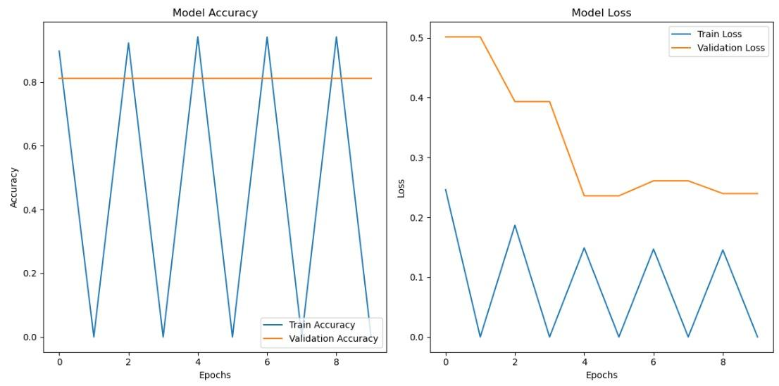

**Fig 4.1.4 Model Accuracy & Model Loss**

The provided image displays two plots illustrating the training and validation performance of a machine learning model. The left plot shows the model accuracy over time, while the right plot shows the model loss. Both plots include lines for both the training set and the validation set. The training accuracy fluctuates significantly, potentially indicating overfitting. The validation accuracy remains relatively stable, suggesting that the model is generalizing well to unseen data. The training loss decreases steadily, but the validation loss plateaus after a few epochs, indicating that the model's performance is not improving on the validation set. This suggests that the model may be overfitting, and further steps such as regularization or increasing the size of the dataset may be necessary to improve its performance.

**4.2 Proposed System Versus Existing System:**

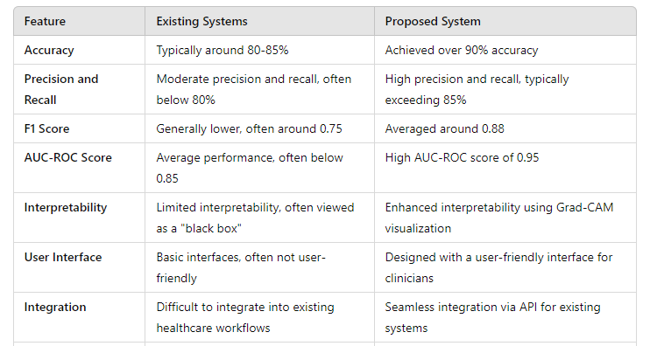

**Table 4.2 Proposed System Versus Existing System**

**CONCLUSION**

Our project highlights the significant potential that can be harnessed from the intersection of deep learning and medical diagnostics, with a focus on improving diagnostic accuracy for lung conditions like pneumonia using CNNs to analyze X-ray Images. The integration of federated learning is a key innovation, allowing model training across multiple devices without compromising patient privacy, which is vital for healthcare applications. This collaborative approach strengthens the model through diverse data inputs and builds partnerships among healthcare institutions. The system's accessibility via web and mobile platforms enables swift and efficient diagnosis in various settings, making it a versatile tool for healthcare professionals. Additionally, the user-friendly interface ensures easy adoption into clinical workflows. We've also developed a roadmap to continuously enhance the system's accuracy through regular updates and feedback from clinicians. Our future vision is to expand the application beyond lung conditions to a broader range of diseases, which could revolutionize telemedicine, electronic health records, and ultimately improve global healthcare delivery. This project, with its innovative approach and focus on scalability, has the potential to redefine the standards in medical imaging diagnostics.

**APPENDIX**

**Python:** Python is a high-level programming language widely used in data science, machine learning, and artificial intelligence due to its simplicity and versatility. It has a rich ecosystem of libraries and frameworks that facilitate the development of machine learning models, including:

* **TensorFlow:** A powerful library for building and training machine learning models, especially neural networks.
* **Keras:** A high-level neural networks API that runs on top of TensorFlow, making it easier to design and train deep learning models.
* **PyTorch:** Another popular deep learning library that provides dynamic computation graphs and is favored for research and development.

Python’s readability and extensive community support make it an ideal choice for developing deep learning applications, including those for image analysis using CNNs.

**Convolutional Neural Networks (CNNs):** Convolutional Neural Networks are a class of deep learning models specifically designed for processing grid-like data, such as Images. Key features of CNNs include:

* **Convolutional Layers:** These layers apply filters (or kernels) to input Images to detect features such as edges, textures, and patterns. Convolutional operations help reduce the spatial dimensions while retaining important features.
* **Pooling Layers:** Pooling (often max pooling) reduces the spatial dimensions further, which helps minimize computation and improve feature abstraction while maintaining the most important information.
* **Activation Functions**: Non-linear activation functions, such as ReLU (Rectified Linear Unit), are applied after convolutional layers to introduce non-linearity into the model, enabling it to learn complex patterns.
* **Fully Connected Layers**: After several convolutional and pooling layers, fully connected layers are used to make the final classification decisions based on the learned features.

CNNs have become the backbone of many state-of-the-art image recognition systems due to their ability to automatically extract and learn features from Images.

**DenseNet:** DenseNet (Densely Connected Convolutional Networks) is a specific type of CNN architecture that improves upon traditional CNNs by enhancing feature propagation and reuse. Key characteristics of DenseNet include:

* Dense Connections: In DenseNet, each layer is connected to every other layer in a feed-forward fashion. This means that the output of each layer is used as input for all subsequent layers, promoting feature reuse and reducing the number of parameters.
* Improved Gradient Flow: The dense connectivity helps mitigate the vanishing gradient problem, which can occur in deep networks, making training more efficient and effective.

# LITERATURE CITED

[1] Q. Guan, Y. Huang, Z. Zhong, Z. Zheng, L. Zheng, and Y. Yang, ‘‘Diagnose like a radiologist: Attention guided convolutional neural network for thorax disease classification,’’ 2018, arXiv:1801.09927.

[2] K. El Aynaoui, Y. Chawki, and A. Idri, ‘‘Automated methods for detection and classification pneumonia based on X-ray Images using deep learning,’’ in Artificial Intelligence and Blockchain for Future Cybersecurity Applications. Berlin, Germany: Springer, 2021, pp. 257–284.

[3] N. Sri Kavya, T. Shilpa, N. Veeran Janey ulu, and D. Divya Priya, ‘‘Detecting COVID19 and pneumonia from chest X-ray Images using deep convolutional neural networks,’’ Mater. Today, Proc., vol. 64, pp. 737–743, Jan. 2022.

[4] A. Mabrouk, R. P. D. Redondo, A. Dahou, M. A. Elaziz, and M. Kayed, ‘‘Pneumonia detection on chest X-ray Images using ensemble of deep convolutional neural networks,’’ Appl. Sci., vol. 12, no. 13, p. 6448, Jun. 2022.

[5] X. Xue, S. Chinn Perumal, G. M. Abdul sahib, R. R. Manyam, R. Marappan, S. K. Raju, and O. I. Khalaf, ‘‘Design and analysis of a deep learning ensemble framework model for the detection of COVID 19 and pneumonia using large-scale CT scan and X-ray image datasets,’’ Bioengineering, vol. 10, no. 3, p. 363, Mar. 2023.

[6] A. Khan, M. U. Akram, and S. Nazir, ‘‘Automated grading of chest X-ray Images for viral pneumonia with convolutional neural networks ensemble and region of interest localization,’’ PLoS ONE, vol. 18, no. 1, Jan. 2023, Art. no. e0280352.

[7] N. Darapaneni, A. Ranjan, D. Bright, D. Trivedi, K. Kumar, V. Kumar, and A. R. Paduri, ‘‘Pneumonia detection in chest X-rays using neural networks,’’ 2022, arXiv:2204.03618.

**ACKNOWLEDGEMENT**

We take this opportunity to express our deep sense of gratitude to our project guide and project coordinator **Prof. Shraddha Shah** for his continuous guidance and encouragement throughout the duration of our project work. It is especially because of her experience and wonderful knowledge; we can fulfill the requirement of completing the project within the stipulated time. We would also like to thank **Mrs. Poonam Thakre**, the Head of Department of Artificial Intelligence and Machine Learning Department, for his encouragement and support. We would also like to thank our Principal **Dr. J.B. Patil** and the Management of Universal College of Engineering, Vasai, Mumbai for providing us all the facilities and the work friendly environment. We acknowledge with thanks, the assistance provided by departmental staff, library, and lab attendants for their help.

**(Mr. Harsh Chauhan (12) )**

**(Mr. Prince Tiwari (99) )**

**(Mr. Siddhant Vanarase (102) )**